Communicate d

Data d

e-mail e

mobile phones e

process d

store d

using technology d

web page e

ICT in business

Administration finance researching development

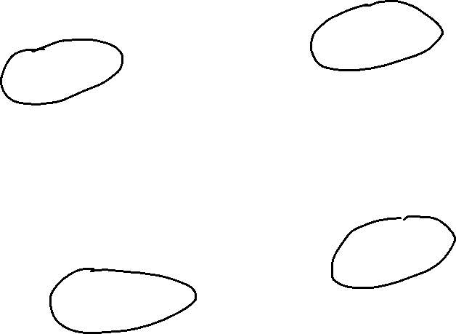

causes

computer

bugs

effects

Areas of business



Administration Finance Research Development

Waterfall model (каскадная модель) – способ организации информации когда упорядоченно все четко разбивается на стадии с определенной последовательностью

3.

4. do you do

5. we arrived / it was rained

6. phoned / she didn’t phone

7. were thinking / I decided

8. are you looking

9. doesn’t rain

10. he wasn’t looking

11. we were going /she was prepared / we didn’t wanted / we didn’t stay

12. told / didn’t believe / he think that a was joking